Condition A:

Duty = 0.3304

GMPP = 400W

GMPP = 400W

Condition B:

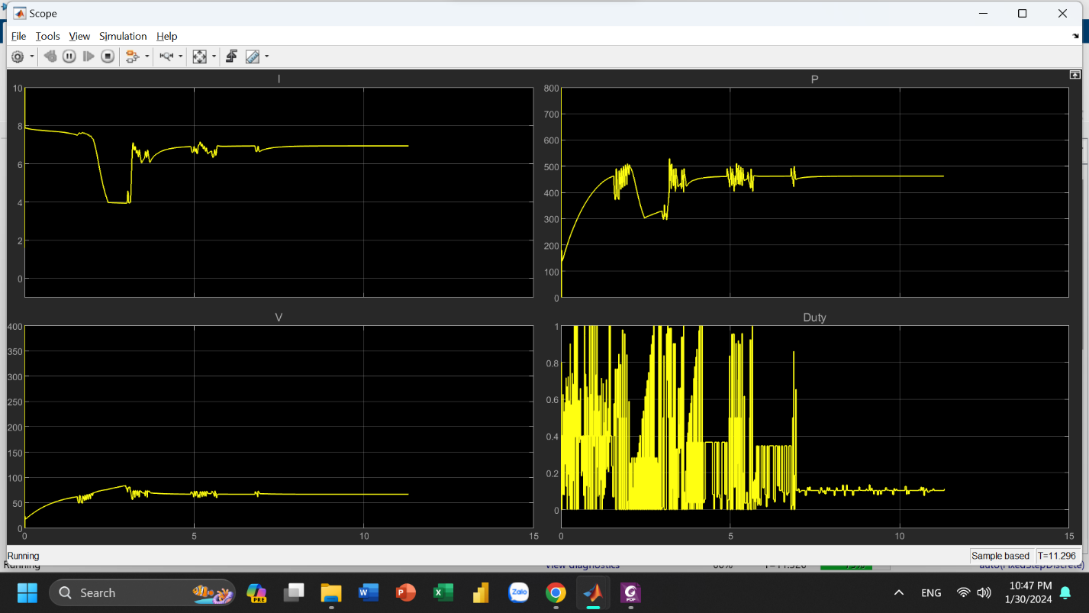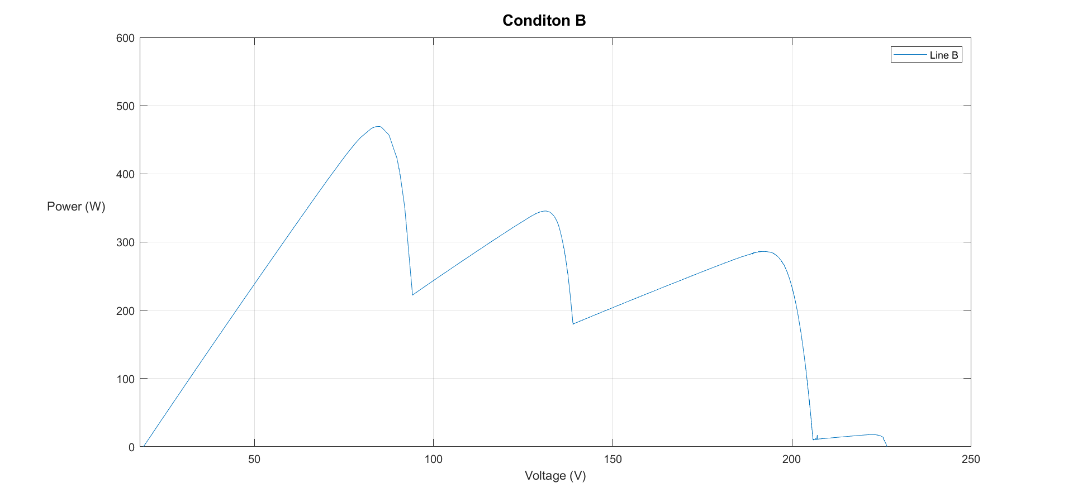

Duty = 0.1035

GMPP = 465W

GMPP = 465W

Condition C:

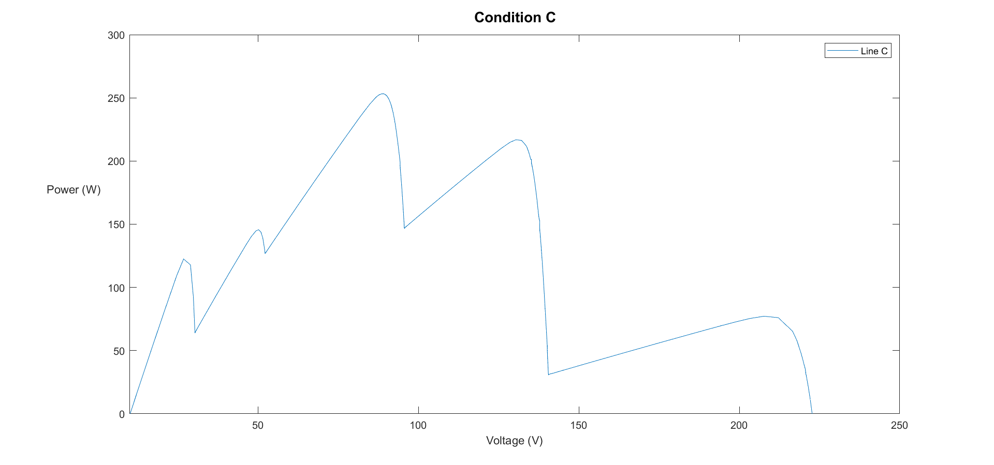

Duty = 0.0373

GMPP = 253.9W

GMPP = 253.9W

Condition D:

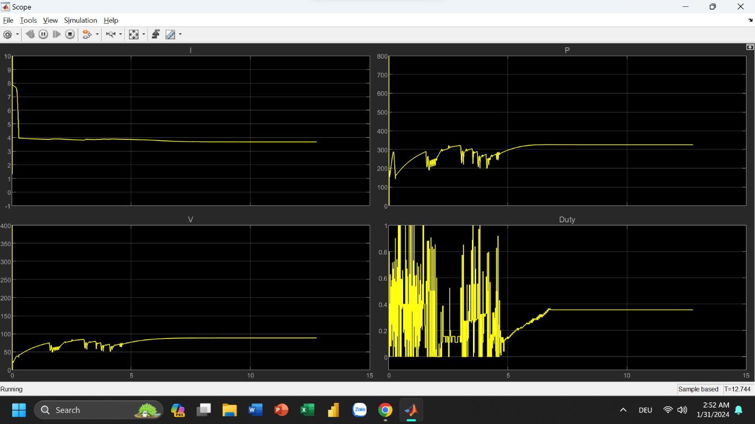

Duty = 0.357

GMPP = 325.1W

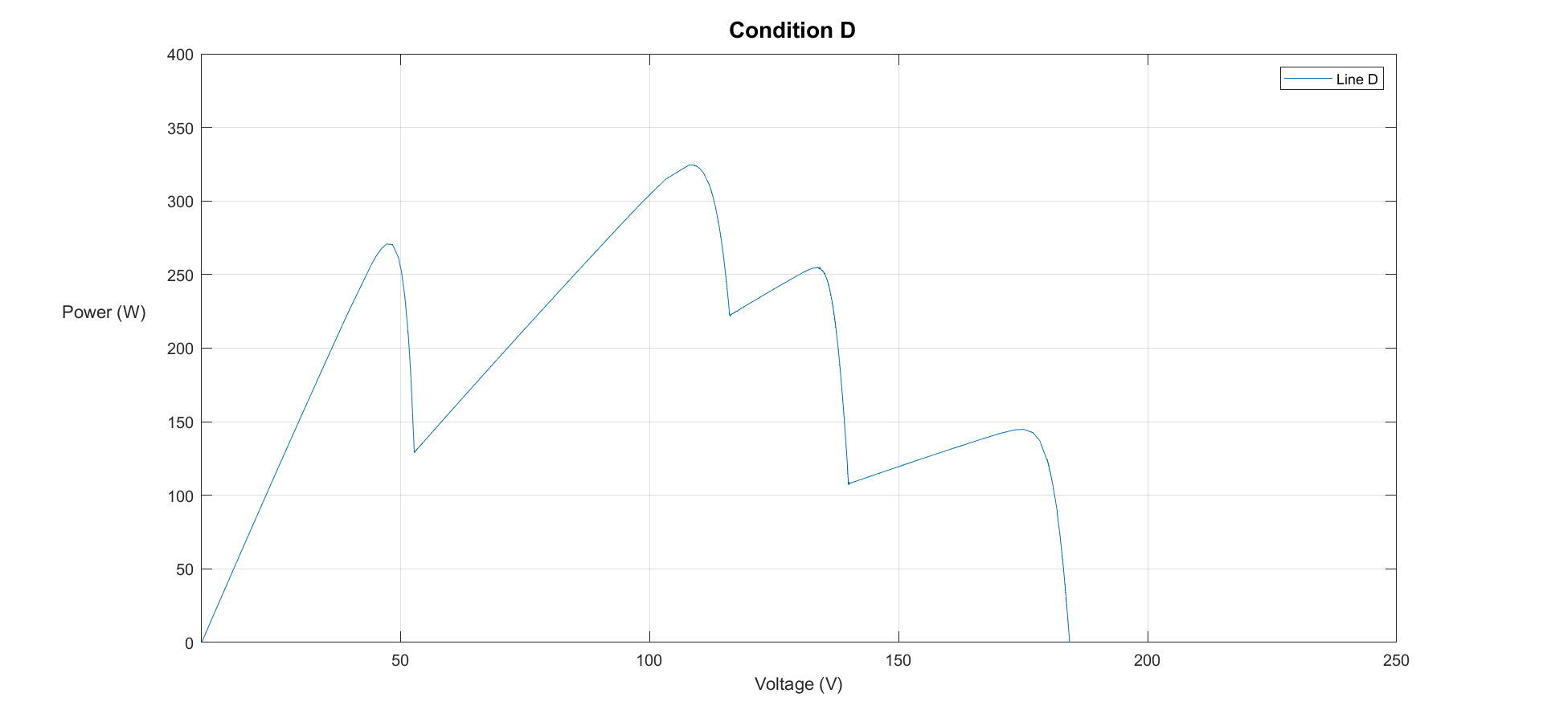

GMPP = 325.1W